**L293D Motor Driver**

**Introduction**

This module is a medium power motor driver perfect for driving DC Motors and Stepper Motors. It uses the popular L293D motor driver IC. It can drive 2 DC motors in both the directions.

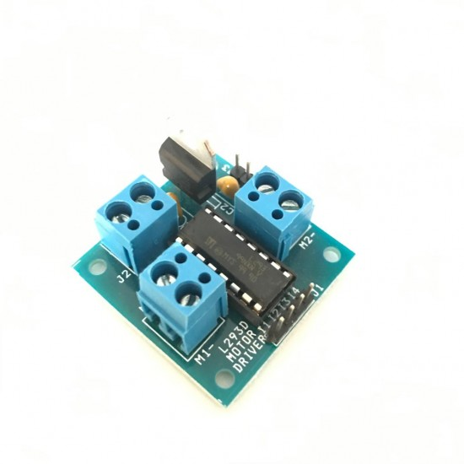

**Working of L293D Motor Driver**

The DC motor’s spinning direction can be controlled by changing polarity of its input voltage. A common technique for doing this is to use an H-Bridge.

An H-Bridge circuit contains four switches with the motor at the center forming an H-like arrangement.

Closing two particular switches at the same time reverses the polarity of the voltage applied to the motor. This causes change in spinning direction of the motor.Below animation illustrates H-Bridge circuit working.



**Working of H-Bridge**

**Hardware Pin Out of L293D**

|  |  |
| --- | --- |
| **Pin Name** | **Description** |
| I1 | Directly controls the Output M1+ pin. Controlled by digital circuits |
| I2 | Directly controls the Output M1- pin. Controlled by digital circuits |
| M1+ | Connected to one end of Motor 1 |
| M1- | Connected to another end of Motor 1 |
| I3 | Directly controls the M2+ pin. Controlled by digital circuits |
| I4 | Directly controls the M2- pin. Controlled by digital circuits |
| M2+ | Connected to one end of Motor 2 |
| M2- | Connected to another end of Motor 2 |
| VIN+ (Vs) | Connected to Voltage pin for running motors (4.5V to 36V) |
| VIN- (GND) | Ground pins are connected to ground of circuit (0V) |
| G | Ground pins are connected to ground of circuit (0V) |
| 5v | Connected to +5V to enable IC function |